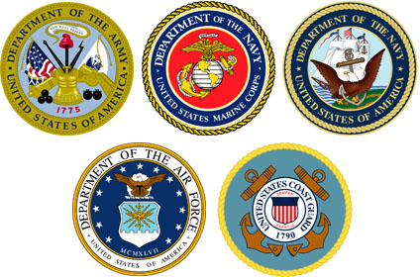
Veterans Day Celebration
Red Ribbon Week ​

​In observance of Veterans Day, USICA High School will be closed on
Wednesday, November 11, 2015

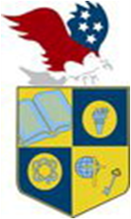
U.S. INTERNATIONAL
CHRISTIAN ACADEMY
is an independent, international autonomous global high school institution

www.USICAhs.org
admin@USICAhs.org

Student Government Association
USICAsga@yahoo.com

