U.S. INTERNATIONAL CHRISTIAN ACADEMY
is an independent, international autonomous global high school institution

Serving students since 2001
Owned and Operated by Teachers
25 years of experience in Teaching and Administration
www.USICAhs.org
admin@USICAhs.org
http://www.usicahs.org/Student-Life-.html
http://www.usicahs.org/News.html

Recommended Activity by Students Government
White House Student Film Festival
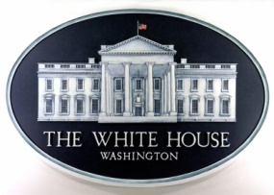
Lights. Camera. Education!
Are you a student filmmaker? Know someone who is? We want your help.
If you're a student, we want you to make a short film -- and have the chance to show it right here at 1600 Pennsylvania Avenue for the first-ever White House Student Film Festival. If you're a parent or a friend, pass this on to a student you know.
The topic? Technology in classrooms. There's huge power in what technology can do for education -- from taking a course online, to collaborating with students from across the country (or the world!).
This is really big news: We're launching our first-ever White House Student Film Festival – and we're
inviting K-12 students from around the country to create and submit a one- to three-minute short
web video. Finalists could have their videos screened at 1600 Pennsylvania Ave, and posted on the
White House website. It might just be cooler than having your homework up on the fridge.

• Every student entry has to have a parent/guardian or teacher sponsor.
• Films can be submitted now through January 29th, 2014.
• If your video is selected as an official selection, you could have a chance to attend the mid-February screening at the White House.
http://www.whitehouse.gov/filmfestival?utm_source=email&utm_medium=email&utm_content=email277-text1&utm_campaign=filmfest

