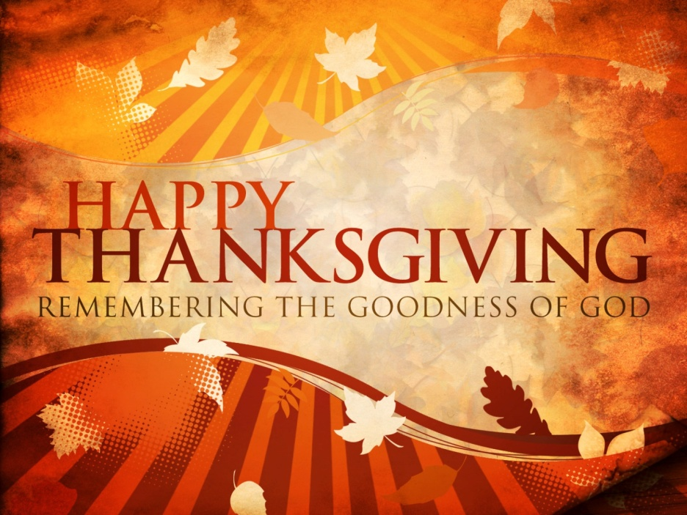
Thanksgiving Day CelebrationRWeek ​
In observance of Thanksgiving Day the School will be closed on
Monday, November 26 through Monday, December 1st, 2014

U.S. INTERNATIONAL
CHRISTIAN ACADEMY
is an independent, international autonomous global high school institution

www.USICAhs.org
admin@USICAhs.org

