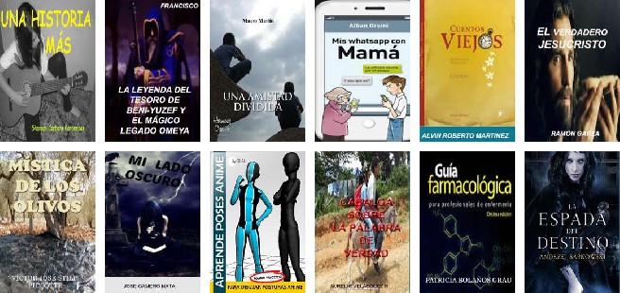
U.S. INTERNATIONAL CHRISTIAN ACADEMY
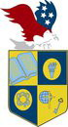
Serving students since 2001
Owned and Operated by Teachers
www.usicahs.orge.mail: admin@USICAHS.ORG
¡Una nueva experiencia!
Esta semana estamos muy contentos de anunciar y celebrar el lanzamiento de la nueva versión de nuestra Web.
Ahora al visitar la biblioteca en línea más grande del Internet, usted podrá navegar de una mejor manera, más rápido y más intuitivo. El nuevo Espanol.Free-eBooks.net está diseñado para que usted encuentre los libros electrónicos que desee desde cualquier dispositivo y aprovechando lo más reciente en la tecnología.
Visite ahora mismo el nuevo Espanol.Free-eBooks.net y descubra las nuevas características que le ofrecemos. Deseamos hacer de su momento de lectura una experiencia más agradable.
También, les presentamos los libros recomendados de esta semana, una selección de nuestros editores y que deseamos compartir con usted.

