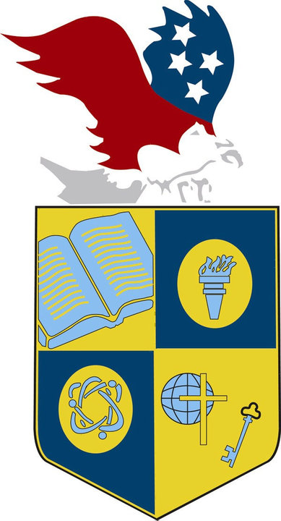
NEWS

www.USICAHS.org
admin@USIUCAhs.org

Serving students since 2001
Owned and Operated by Teachers
with 25 years of experience in Teaching and Administration

U.S. international Christian Academy is celebrating the 50th anniversary of Martin Luther King's "I Have A Dream" speech

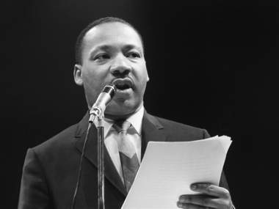
An address by President Barack Obama has capped celebrations marking the 50th anniversary of Martin Luther King's "I Have A Dream" speech.
Mr Obama spoke on the steps of Washington's Lincoln Memorial, the site of Dr King's iconic address on August 28, 1963. "We rightly and best remember Dr King’s soaring oratory that day - how he gave mighty voice to the quiet hopes of millions," Mr Obama said.
"His words belong to the ages, possessing a power and prophecy unmatched in our time. It was a moment rich with history and symbolism, with the first black president standing where Dr King first sketched his dream.
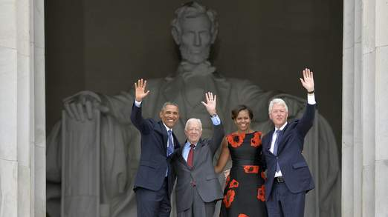
U. S. INTERNATIONAL CHRISTIAN ACADEMY
School
NEWSLETTER



