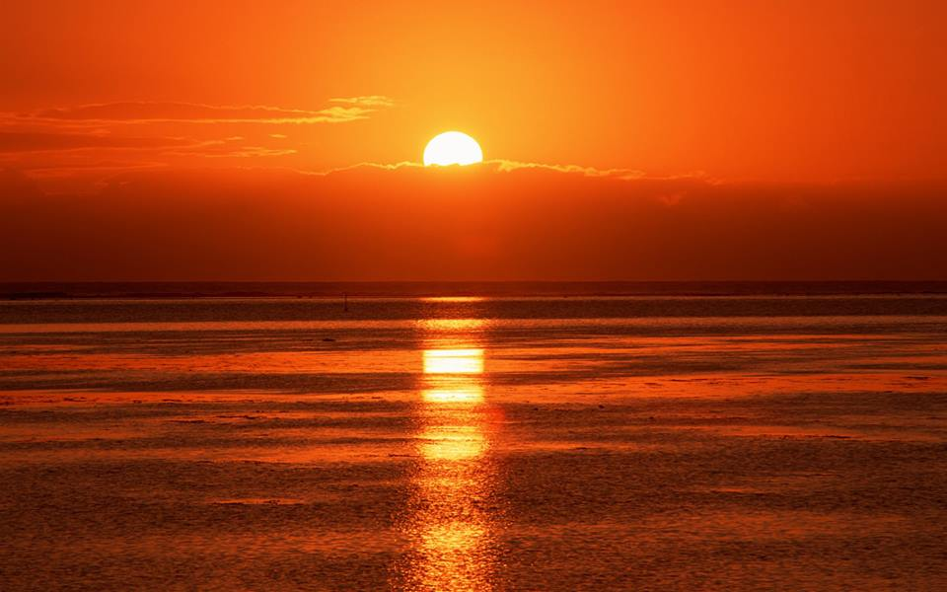
Happy Summer..!

SUMMER TERMS

Summer I
Monday, June 15th -Friday, July 10th
Friday, July 3th Independence Day Weekend-No School

Summer II
Monday, July 13th- Friday, August 7th

U.S. INTERNATIONAL CHRISTIAN ACADEMY
www.usicahs.org
admin@USICAHS.ORG

