U.S. INTERNATIONAL CHRISTIAN ACADEMY
is an independent, international autonomous global high school institution

Serving students since 2001
Owned and Operated by Teachers
25 years of experience in Teaching and Administration
www.USICAhs.org
admin@USICAhs.org
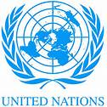
http://www.usicahs.org/Library.html
http://www.usicahs.org/Curriculum.html

USICA Course Outline/Syllabus
Grade/Course: WORLD CURTURAL GEOGRAPHY 2103300
Grade Level: 9th High School
A)TEXT BOOK: World Geography Today: SE WLD GEOG TODAY 2005 2005 [Hardcover]
RINEHART AND WINSTON HOLT (Author)
ISBN-10: 0030646820 | ISBN-13: 978-0030646829
Order No.: 1 |  | Code:GEO3000 | Class Type: Online
Resources:  Text book  Teacher works CD Teacher interactive online  Links |  |  | Instructional Supports:  Textbook, Magazines, Journals, Websites Links, Conference,  A.A. Geography Resources, Comprehensive Reading Plan
Skype Conference  CNN Resources |  | Length: 1 year
Area: Social Studies |  | Credits: 1 | Total Numbers of class hours:300 hrs
Type: Mandatory |  | Standards:  Florida Sunshine State Standards | Prerequisite:  Students must have successfully passed a Social Studies/Geography class in  Middle and high school.

B) Description:

This one-year World Geography course emphasizes the study people, places,
and environments at local, regional, national, and international levels from the
ecological, cultural, physical science, and human perspectives of geography. The social studies standards of essential content knowledge and process skills are integrated for instructional purposes using multimedia tools and technology resources.
.
Geography enables the students to see, understand and appreciate the web
of relationships between people, places, and environments.

Culture encompasses similarities and differences among people, including their beliefs,
knowledge, changes, values, and tradition. Students will explore these elements of
society to develop an appreciation of and respect for the variety of human cultures.

C) Objectives:

- The student will understand fundamental geography concepts and their application of economic systems, regionally and globally.
- to develop in all students to investigate the nature of the World Geography
- The student will understand the complex nature of culture and how cultures influence the
- characteristics of places and regions.
- The Student will understand the relationship between physical environments and culture
- The students will participate in a teacher created simulation of various types of economies.
- The student will understand the characteristics and uses of maps, globes, and other geographic tools and technologies.
- The Student will understand that common physical, biological, and cultural characteristics

D) Contents

UNIT 1 The Geographer’s World
Chapter 1 Studying Geography
Chapter 2 Earth in Space
Chapter 3 Weather and Climate
Chapter 4 Landforms, Water, and Natural Resources
Chapter 5 Human Geography
Chapter 6 Human Systems

UNIT 2 The United States and Canada
Chapter 7 Natural Environments of North America
Chapter 8 The United State
Chapter 9 Canada

UNIT 3 Middle and South America
Chapter 10 Mexico
Chapter 11 Central America and the Caribbean
Chapter 12 South America

UNIT 4 Europe
Chapter 13 Natural Environments of Europe
Chapter 14 Northern and Western Europe
Chapter 15 Central Europe
Chapter 16 Southern Europe and the Balkans

UNIT 5 Russia and Northern Eurasia
Chapter 17 Russia, Ukraine and Belarus
Chapter 18 Central Asia

UNIT 6 Southwest Asia
Chapter 19 The Persian Gulf and Interior
Chapter 20 The Eastern Mediterranean

UNIT 7 Africa
Chapter 21 North Africa
Chapter 22 West and Central Africa
Chapter 23 East Africa
Chapter 24 Southern Africa

UNIT 8 South Asia
Chapter 25 India
Chapter 26 The Indian Perimeter

UNIT 9 East and Southeast Asia
Chapter 27 China, Mongolia, and Taiwan
Chapter 28 Japan and the Koreans
Chapter 29 Mainland Southeast Asia
Chapter 30 Island Southeast Asia

UNIT 10 The Pacific World
Chapter 31 Australia and New Zealand
Chapter 32 The Pacific Islands

E. Methodology
E)Academic Methodology:

Tests | 30%
Writing Reports | 20%
Homework | 5%
Class Work | 20%
Reading Assignment | 25%

F) Book Reference:
1.The World Today: Concepts and Regions in Geography 4th Edition (Book Only) Unknown Binding – January 1, 2009 by [REVIEW ONLY] - CramReviewText101Outlines (Author)
2.The World Today: Concepts and Regions in Geography [Paperback] by Harm J. de Blij, Peter O. Muller and Jan Nijman (Authors)
3.World Geography Today: 1995 Hardcover – January 1, 1995 by Robert J. Sager (Author)
4. Wiley/National Geographic College Atlas of the World [Paperback] Harm J. de Blij and
Roger Downs (Authors)
5.Holt World Geography Today, Map Activities [Student Edition] [Paperback] RINEHART AND WINSTON HOLT (Author)
6.Chapter Tutorials for Students, Parents, Mentors and Peers Holt World Geography Today [Student Edition] [Paperback] RINEHART AND WINSTON HOLT (Author)
7.World Geography Today [Hardcover] by David M. Helgren (Author)

H) Web Reference:

www.worlgeography.org
www.factmonster.com/ipka/A0770414.html
www.geographyworldonline.com
www.linkstolearning.com/links/world_geography-high
www.sheppardsoftware.com/Geography.htm
www.geography.about.com
www.en.wikipedia.org/wiki/Geography
www.enchantedlearning.com/geography
www.worldculturesandgeo.weebly.com/resources.html
www.lafayettejeff.org/.../world_geography_links.htm
www.experiencegeography.net/links
www.worldmapsonline.com/geographylinks.htm
www.cmsdnet.net/en/Resources/Students/Geography.aspx
www.solarnavigator.net/geography/geography_links.htm
www.1worldglobalgifts.com/links_to_geography.htm
http://geographyworldonline.com/magazines.html

I. Journals:

Journal of the Royal Geographical Society of London
Journal of the American Geographical and Statistical Society
Geographical Review
Journal of Geography in Higher Education
Journal of the American Geographical Society of New York
International Journal of Geographical Information Science
Journal of World Prehistory
Journal of Coastal Research
Journal of Economic Geography
Journal of Historical Geography
Journal of Latin American Geography
Journal of Map & Geography Libraries
Journal of Third World Studies
Journal of Transport Geography

J.Magazines:

Smithsonian magazine, published by the Smithsonian Museum
Geographic Information Sciences
Geographical Analysis
Geographical Education
Geographical Journal
Geographical Viewpoint
Geography Research Forum
Geography Review
Geomorphology

K. Organizations:

The American Association of Geography
Geographical Association

M. Comprehensive Reading Plan
Students are required to read at least 1 book or their equivalent during each class
as independent reading at-home. Students must also read for 30 minutes at home as part of their daily homework assignment in all subjects. Check your Class Reading Assignment at www.USICAhs.org/CURRICULUM and check free ebooks at www.openlibrary.org .

Text Book Description:

Publication Date: August 6, 2002 | ISBN-10: 0030646820 | ISBN-13: 978-0030646829 | Edition: 1

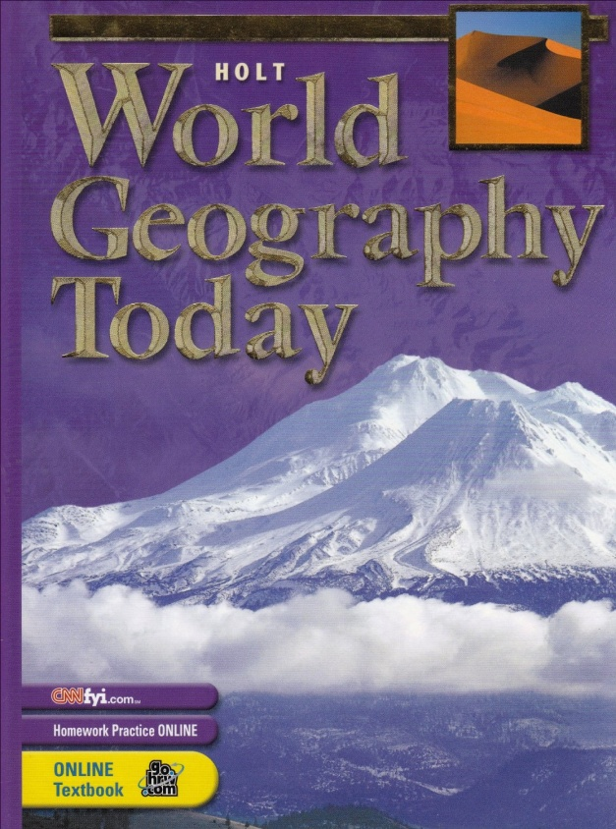

ACADEMIC MISCONDUCT:

Academic misconduct includes cheating (using unauthorized materials, information, or study aids in any academic exercise), plagiarism, falsification of records, unauthorized possession of examinations, intimidation, and any and all other actions that may improperly affect the evaluation of a student’s academic performance or achievement, or assisting others in any such act or attempts to engage in such acts. Academic misconduct in any form is inimical to the purposes and functions of the school and therefore is unacceptable and prohibited.
Any faculty member, administrator or staff member may identify an act of academic misconduct and should report that act to the department head or administrative supervisor.
Students violating the standards of academic honesty are subject to disciplinary action including reduction of a grade(s) in a specific course, assignment, paper, or project; a formal or informal reprimand at the professorial, dean, or academic vice president level; expulsion from the class in which the violation occurred; expulsion from a program; or expulsion from the school.

U.S. International Christian Academy © 2013
Revised on JUNE 21, 2013 USICA Copyright

