U.S. INTERNATIONAL CHRISTIAN ACADEMY
is an independent, international autonomous global high school institution

Serving students since 2001
Owned and Operated by Teachers
25 years of experience in Teaching and Administration
www.USICAhs.org
admin@USICAhs.org
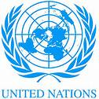
http://www.usicahs.org/Library.html
http://www.usicahs.org/Curriculum.html

USICA Course Outline/Syllabus
Grade/Course: CHEMISTRY I 2003340
Grade Level: 12thHigh School
A)TEXT BOOK: CHEMISTRY REVISED 5 EDITION STUDENT EDITION 2002C [Hardcover]ADDISON WESLEYPRENTICE HALL (Author)
ISBN-10: 0130543845 | ISBN-13: 978-0130543844
Order No.: 1 |  | Code:CHE2003 | Class Type:Online
Resources:  Text book  Teacher works CD Teacher interactive online  Links |  |  | Instructional Supports:  Textbook, Magazines, Journals, Websites Links, Conference, Comprehensive Reading Plan
Sky Conference |  | Length: 1 year
Area:Science |  | Credits: 1 | Total Numbers of class hours:300 hrs
Type: Mandatory |  | Standards:  Florida Sunshine State Standards | Prerequisite:  Students must have successfully passed a Science class in middle/high school.

B) Description:

This one-year course of emphasizes the study of the properties and nature of matter and energy. This course explores the periodic table, chemical bonding and including chemical equations, reaction kinetics, and the processes of reactions.This course offers a solid understanding of the fundamentals concepts of chemistry. Problem solving is presented logically one step at a time.

C) Objectives:

- To develop in all students an appreciation and solutions to all types of Chemistry based interactions and problems.
- topromote in all students an introduction to the study of Chemistry.
- to promote the technology tools designed to inspire today’s chemistry students.

D) Contents

Chapter 1 Introduction to Chemistry

Chapter 2 Matter and Change

Chapter 3 Scientific Measurement

Chapter 4 Problem Solving in Chemistry

Chapter 5 Atomic Structure and the Periodic Table

Chapter 6 Chemical Names and Formulas

Chapter 7 Chemical Quantities

Chapter 8 Chemical Reactions

Chapter 9 Stoichiometry

Chapter 10 States of Matter

Chapter 11 Thermochemistry Heat and Chemical Change

Chapter 12 The Behavior of Gases

Chapter 13 Electrons in Atoms

Chapter 14 Chemical Periodicity

Chapter 15 Ionic Bonding and Ionic Compounds

Chapter 16 Covalent Bonding

Chapter 17 Water and Aqueous Systems

Chapter 18 Solutions

Chapter 19 Reaction Rates and Equilibrium

Chapter 20 Acid and Bases

Chapter 21 Neutralization

Chapter 22 Oxidation- Reduction Reactions

Chapter 23 Electrochemistry

Chapter 24 The Chemistry of Metals and Nonmetal

Chapter 25 Hydrocarbon Compounds

Chapter 26 Functional Groups and Organic Reactions

Chapter 27 The Chemistry of Life

Chapter 28 Nuclear Chemistry

E. Methodology
E)Academic Methodology:

Tests | 30%
Writing Reports | 20%
Homework | 5%
Class Work | 20%
Reading Assignment | 25%

F) Book Reference:
1.Chemistry: Concepts and Problems: A Self-Teaching Guide (Wiley Self-Teaching Guides) [Paperback]
Clifford C. Houk and Richard Post (Authors)
2.Homework Helpers: Chemistry [Paperback] Greg Curran (Author)
3.Chemistry [Hardcover] by Steven S. Zumdahl (Author)
4.Chemistry, Grades 9 - 12 (The 100+ Series) Paperback – January 15, 1999 by Joan Distasio (Author)

H) Web Reference:

www.acs.org
www.Chemistry.com
www.chemistry24.com
www.sciencespot.net/Pages/kdzchem.html
www.chemtopics.com/links.htm
www.iv.ac.uk/Chemistry/Links/links.html
www.tvmuse.eu/tv-shows/Chemistry_26950
www.chem.ucla.edu/chempointers.html
www.chemtopics.com/wwwchem.htm
www.101science.com/Chemistry.htm

I. Journals:

American Scientist
Science
Scientific American
Chemistry Today

J.Magazines:

Smithsonian magazine, published by the Smithsonian Museum
American Scientist magazine
Discover magazine

K.Organizations

Science Foundation
National Chemistry Association
Association of Chemistry Teachers

M. Comprehensive Reading Plan
Students are required to read at least 1 book or their equivalent during each class
as independent reading at-home. Students must also read for 30 minutes at home as part of their daily homework assignment in all subjects. Check your Class Reading Assignment at www.USICAhs.org/CURRICULUM and check free ebooks at www.openlibrary.org .

Text Book Description

Publication Date: February 1, 2001 | ISBN-10: 0130543845 | ISBN-13: 978-0130543844 | Edition: 5th. The #1 choice for high school Chemistry

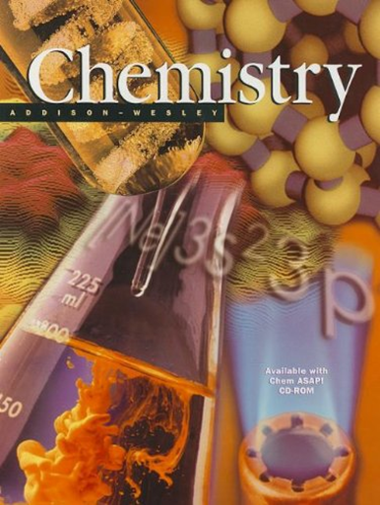

ACADEMIC MISCONDUCT:

Academic misconduct includes cheating (using unauthorized materials, information, or study aids in any academic exercise), plagiarism, falsification of records, unauthorized possession of examinations, intimidation, and any and all other actions that may improperly affect the evaluation of a student’s academic performance or achievement, or assisting others in any such act or attempts to engage in such acts. Academic misconduct in any form is inimical to the purposes and functions of the school and therefore is unacceptable and prohibited.
Any faculty member, administrator or staff member may identify an act of academic misconduct and should report that act to the department head or administrative supervisor.
Students violating the standards of academic honesty are subject to disciplinary action including reduction of a grade(s) in a specific course, assignment, paper, or project; a formal or informal reprimand at the professorial, dean, or academic vice president level; expulsion from the class in which the violation occurred; expulsion from a program; or expulsion from the school.

U.S. International Christian Academy © 2013
Revised on JUNE 21, 2013 USICA Copyright

