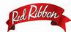

Red Ribbon Celebration
Red Ribbon Week ​

U.S. International Christian Academy is celebrating
Red Ribbon Week October 23-31
​

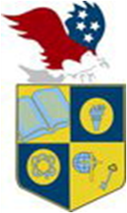
U.S. INTERNATIONAL
CHRISTIAN ACADEMY
is an independent, international autonomous global high school institution

www.USICAhs.org
admin@USICAhs.org

Student Government Association
USICAsga@yahoo.com

