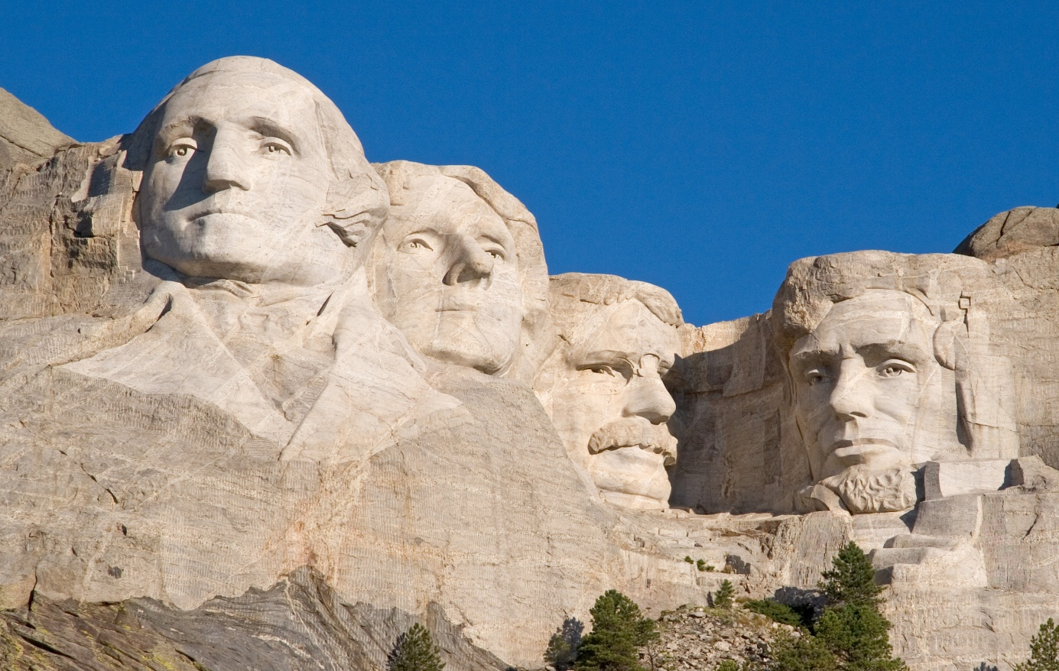
The Mount Rushmore National Memorial is a sculpture carved into the granite face of Mount Rushmore (Lakota Sioux name: Six Grandfathers) near Keystone, South Dakota, in the United States. Sculpted by Danish-American Gutzon Borglum and his son, Lincoln Borglum, Mount Rushmore features 60-foot (18 m) sculptures of the heads of four United States presidents: George Washington (1732–1799), Thomas Jefferson (1743–1826), Theodore Roosevelt (1858–1919), and Abraham Lincoln (1809–1865)

Happy Presidents Day
U.S. INTERNATIONAL CHRISTIAN ACADEMY
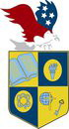
an independent, international autonomous global high school institution

www.USICAhs.org
admin@USICAhs.org

In observance of Presidents Day, U.S. International Christian Academy will be closed
Monday, February 16th, 2015anuary

