U.S. INTERNATIONAL CHRISTIAN ACADEMY
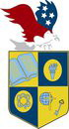
is an independent, international autonomous global high school institution

Serving students since 2001
Owned and Operated by Teachers
25 years of experience in Teaching and Administration
www.USICAhs.org
admin@USICAhs.org
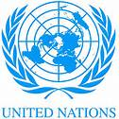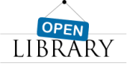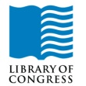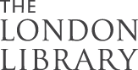
http://www.usicahs.org/About-USICA.html

Presidential Libraries

George Bush Presidential Library
http://bushlibrary.tamu.edu
Jimmy Carter Library
http://carterlibrary.galileo.peachnet.edu
Dwight D. Eisenhower Presidential Library
http://www.eisenhower.utexas.edu/ddehp.htm
Eisenhower Center
http://history.cc.ukansas.edu/heritage/abilene/ikectr.html
Gerald R. Ford Library
http://www.lbjlib.utexas.edu/ford/
Rutherford B. Hayes Presidential Center
http://www.rbhayes.org
Herbert Hoover Presidential Library
http://www.hoover.nara.gov
John Fitzgerald Kennedy Library
http://www.cs.umb.edu/jfklibrary/index.htm

Lyndon B. Johnson Library and Museum
http://www.lbjlib.utexas.edu/
McKinley Memorial Library
http://www.mckinley.lib.oh.us/
Richard Nixon Library and Birthplace Foundation
http://www.nixonfoundation.org/
Ronald W. Reagan Presidential Library
http://www.reaganfoundation.org
http://www.webportal.com/reaganlibrary/
Franklin D. Roosevelt Library and Museum
http://www.fdrlibrary.marist.edu
Harry S. Truman Library & Museum
http://www.trumanlibrary.org

