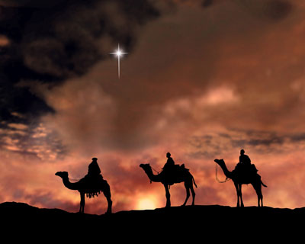
"Three Kings Celebration"
The Magi, also referred to as the (Three) Wise Men or (Three) Kings were, in the Gospel of Matthew and Christian tradition, a group of distinguished foreigners who visited Jesus after his birth, bearing gifts of gold, frankincense and myrrh. They are regular figures in traditional accounts of the nativity celebrations of Christmas and are an important part of Christian tradition. According to Matthew, the only one of the four Canonical gospels to mention the Magi, they came "from the east" to worship the "king of the Jews".[2] Although the account does not mention the number of people "they" or "the Magi" refers to, the three gifts has led to the widespread assumption that there were three men.[3] In Eastern Christianity, especially the Syriac churches, the Magi often number twelve. Their identification as kings in later Christian writings is probably linked to Psalms 72:11,
"May all kings fall down before him".

U.S. INTERNATIONAL CHRISTIAN ACADEMY
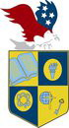
www.usicahs.org
admin@USICAHS.ORG

