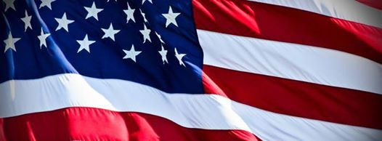

Happy 4th of July 2015
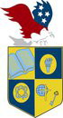
U.S. INTERNATIONAL CHRISTIAN ACADEMY
Serving students since 2001
Owned and Operated by Teachers
www.usicahs.org
admin@USICAHS.ORG
https://www.facebook.com/pages/US-INTERNATIONAL-CHRISTIAN-ACADEMY/110368659002927
https://twitter.com/USICAHighSchool
Student Government Association
www.USICAsga@yahoo.com

