U.S. INTERNATIONAL CHRISTIAN ACADEMY
Serving students since 2001
Owned and Operated by Teachers
with 25 years of experience in Teaching and Administration
www.usicahs.org
e.mail: admin@USICAHS.ORG

USICA NEWS

Suggested Reading

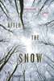
After the Snow
S. D. Crockett
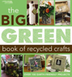
The Big Green Book of Recycled Crafts
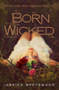
Born Wicked
Jessica Spotswood
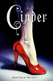
Cinder
Marissa Meyer
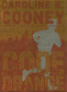
Code Orange
Caroline Cooney
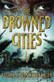
The Drowned Cities
Paolo Bacigalupi

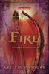
Fire
Kristin Cashore
Generation Green: The Ultimate Teen Guide to Living an Eco-Friendly Life
Linda Sivertsen
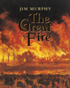
The Great Fire
Jim Murphy

Guy Langman, Crime Scene Procrastinator
Josh Berk
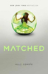
Matched
Allyson Condie
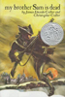
My Brother Sam is Dead
James Collier

http://www.mdpls.org/programs/summer-reading/summer-reading-teens.html

