

USICA School Newspaper

Academic Year 2015-16 www.usicahs.org
SCHOOL NEWS TODAY

U.S. International Christian Academy

Serving students since 2001
Owned and Operated by Teachers
25 years of experience in Teaching and Administration
www.usicahs.org
admin@USICAHS.ORG



School Calendar 2014-2015

First Semester

Monday, August 24th, First day of school
Monday, September 7 – Labor Day – no school
Monday, October 12th, Christopher Columbus Day – no school
Friday, November 6st – Faculty day – no school
Wednesday, November 11th – Veterans’ day – no school
Thursday, November 26th- Thanksgiving holiday -no school
Friday, December 18th – School Christmas Vacations
Monday, December 21th – Faculty day – no school

Second Semester
Monday, January 4th, First Day
Monday, January 16th,Martin Lither King Birthday No School
Monday, February 15th, Presidents’ Day – no school
Wednesday, March 16th, Spring break – no school
Monday, March 18-27, Holly Week no-school
Thursday, March 24th – Easter recess – no school
Monday, March 28h– school resumes
Monday, May 30th– Memorial Day – no school
Friday, June 10th– last day of school
Monday, June 12th – Faculty day

By Ana Fuentes

HOLY WEEK

Holy Week is the last week of Lent, the week immediately preceding Easter or Resurrection Sunday.

It is observed in many Christian churches as a time to commemorate and enact the suffering (Passion) and death of Jesus through various observances and services of worship. While some church traditions focus specifically on the events of the last week of Jesus’ life, many of the liturgies symbolize larger themes that marked Jesus’ entire ministry. Observances during this week range from daily liturgical services in churches to informal meetings in homes to participate in a Christian version of the Passover Seder.Happy Easter..!

Student Goverment Association

The government of student body is a student organization presentthe students. The students' union is often dedicated to social, organizational activities, representation and academic support of the membership.



INSERT YOUR ARTICLE TITLE HERE





Hispanic Celebration 2015

​In Observation of Hispanic Celebration Day, USICA High School will be closed Monday October 12, 2014 Celebrating Hispanic Month
​Sponsor by Spanish Club “Viva Espana”
This club promotes an understanding of the Spanish culture, Literature, Music and Customs.

USICASpanishClub@yahoo.com

USICA HIGH SCHOOL NEWS
MEMORIAL DAY
INDEPENDENCE
CELEBRATION
LABOR’S DAY

EASTER DAY!

In observance of Holly Week and Easter Day, USICA HIGH SCHOOL will be closed from Wed, April15th through Monday, April 29h, 2016.
HAPPY EASTER DAY!

CONSTITUTION DAY
Thrusday, September 17, 2015
Book Club

Members discuss and share good books, hear about new books which are being added to the school library and are encouraged to suggest books for purchase.
e.mail: ​USICABokkClub@yahoo.com
In observance of Memorial Day, USICA HIGH SCHOOL will be closed Monday, May 25h, 2016

WELCOME

Welcome to U.S. internatioal Christian Academy
academic year 2015-16

Veterans Day
​In observance of Veterans Day, USICA High School will be closed on Tuesday, November 11, 2015
In Observance of Independence Day, July 4th USICA High School will be close.
Happy 4th July

Red Ribbon Week ​

U.S. International Christian Academy is celebrating
Red Ribbon Week
​Student Goverment Association (S.G.A.)

BOOKSTORE

Visit our Bookstore at
http://usica02.wix.com/
usicabookstore#

This club is open to all students. The basic goal is to promote respect
for life from conception to natural death.
In observance of Labor's Day, USICA High School will be closed on Monday,
September 7nd, 2015

THANKSGIVING

In observance of Thanksgiving Day,
The School will be closed on Monday, November 265 through Tuesday, December 1st, 2015

Pro-Life Club

This club is open to all students. The basic goal is to promote respect
for life from conception to natural death.



Extra-curiculars

As stated in our philosophy, "through academic, spiritual, athletic, extracurricular, and service programs, USICA provides the opportunity for students to discover, develop, and use their God-given talents". Many extra-curricular activities are available at to help meet this goal outside of the formal classroom environment.
U.S.I.C.A. Student Goverment Association

The government of student body is a student organization presentthe students. The students' union is often dedicated to social, organizational activities, representation and academic support of the membership.
​email: USICASGAStudent Council@yahoo.com

Extra Curriculars

As stated in our philosophy, "through academic, spiritual, athletic, extracurricular, and service programs, USICA provides the opportunity for students to discover, develop, and use their God-given talents". Many extra-curricular activities are available at to help meet this goal outside of the formal classroom environment.

U.S.I.C.A. Student Goverment Association

The government of student body is a student organization presentthe students. The students' union is often dedicated to social, organizational activities, representation and academic support of the membership.

​email: USICASGAStudent Council@yahoo.com

USICA HIGH SCHOOL NEWS
FELIZ 2015
ANNIVERSARY
CELEBRATION

THANKSGIVING
Happy Thanksgiving Day

"Give thanks to the LORD, for he is good;
his love endures forever."
1 Chronicles 16:34

At this time of
Thanksgiving celebration
our thoughts turn gratefully
to you with
warm appreciation



THANKSGIVING

In observance of Thanksgiving Day,USICA High School will be closed on Wednesday, November 25 - Monday, December 1st, 2015

XMAS HOLIDAYS
In observance of Xmas Holiday and New Year, USICA HIGH SCHOOL will be closed from Friday, December 18th through
January 4, 2016
MARTIN L. KING,Jr.
Monday, January 4
observance of Martin Luther King,Jr., USICA HIGH SCHOOL will be closed Monday, January 18th, 20162015
HAPPY NEW YEAR 2016

Welcome to U.S. internatioal Christian Academy
academic year 2015-16

Presidents Day

​In observance of Presidents Day,
USICA HIGH SCHOOL will be closed Monday,
February15th, 2016

In Observance of anniversary Day, Friday, May 16th USICA High School will be closed.

BOOKSTORE
Visit our Bookstore at
http://usica02.wix.com/
usicabookstore#

HAPPY ST. VALENTINE’S

Sunday, February 14, 2016

CODE OF BEHAVIOR

Individual development, individual responsibility, and a respect for each individual within society are at the root of our program. Our code of behavior reflects this commitment while fostering the skills and attitudes that are
necessary in order to
become responsible citizens.
We expect all members of our school community -- students, teachers, and parents or guardians -- to set an example which will result in U.S. International Christian Academy being a zone of zero-tolerance for vandalism, violence, racism, illegal substances and harassment.

FUNDRAISER PROJECTS

No student may solicit funds in the school’s name unless such solicitation has been authorized in writing by the principal.

FundingFactory Recycling Fundraiser

U.S. International Christian Academy is participating in recycling fundraiser collecting inkjet and toner cartridges, cell phones, MP3 players, digital cameras, GPS devices, headsets, and laptops for cash for Fundraiser for U.S. International Christian Academy Schoolarship Funds.

U.S. INTERNATIONAL CHRISTIAN ACADEMY
Serving students since 2001
Owned and Operated by Teachers
25 years of experience in Teaching and Administration
www.usicahs.org
admin@USICAHS.ORG

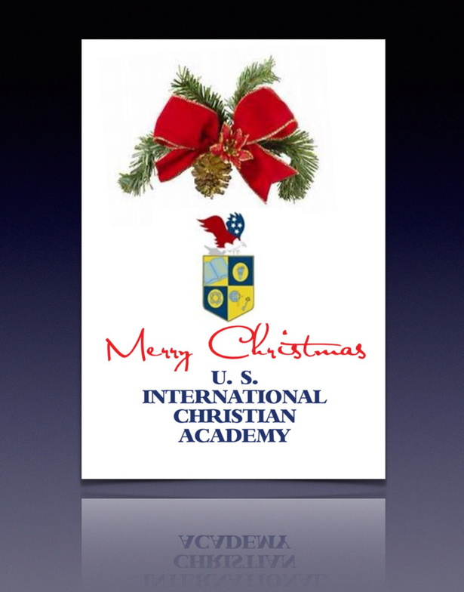

Visit our website: www.usicahs.org
e.Library: www.usicahs.org/library
Facebook: https://www.facebook.com/pages/US-INTERNATIONAL-CHRISTIAN ACADEMY/110368659002927
Twitter: https://twitter.com/USICAHighSchool
Youtube: https://www.youtube.com/user/USICAHighSchool
Follow us at Instagram

Please see our website www.usicahs.org and the following links:

Home Page
http://www.usicahs.org
History of the School/Mission/Vision/Program
http://www.usicahs.org/About-USICA.html
Admission Process
http://www.usicahs.org/Admissions.html
Curriculum/Courses/Syllabus/Academics
http://www.usicahs.org/Curriculum.html
Applications/Forms
http://www.usicahs.org/College-Orientation.html
eLibrary/Resources/Tutoriasls/Links
http://www.usicahs.org/Library.html
Students organizations/School Activities
http://www.usicahs.org/Student-Life-.html
Graduation/College Orientation
http://www.usicahs.org/Graduation.html
Community Services
http://www.usicahs.org/Community-Services.html
School Calendar/School News
http://www.usicahs.org/Calendar-.html
School News/Newsbulletin/Events
http://www.usicahs.org/News.html
Recongnitions/Letters/Proclamarions
http://www.usicahs.org/Recognitions.html
Books/Bookstore
http://www.usicahs.org/Donations.html
Payments/Fundraiser/Donations
http://www.usicahs.org/Payments.html
eStore/School Supplies
http://www.usicahs.org/e-Store.html
Bookstore/Text Books/ebooks/Best Seller
http://usica02.wix.com/usicabookstore#
Academic Documentaries & Videos
www.usica02.wix.com/LiveScience
www.usica02.wix.com/SocialStudies

Show your USICA High School SPIRIT...eStore http://www.usicahs.org/e-Store.html

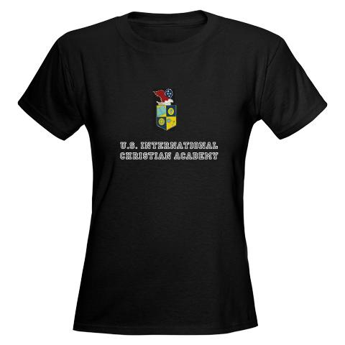
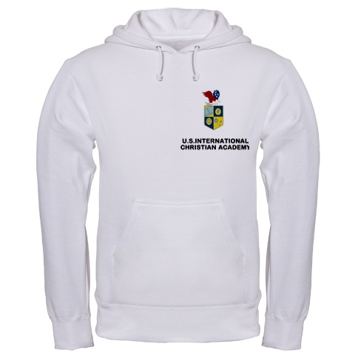

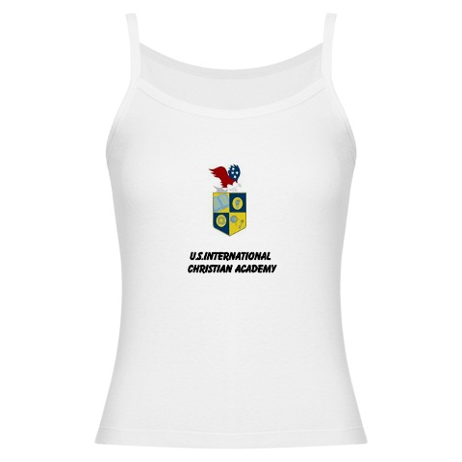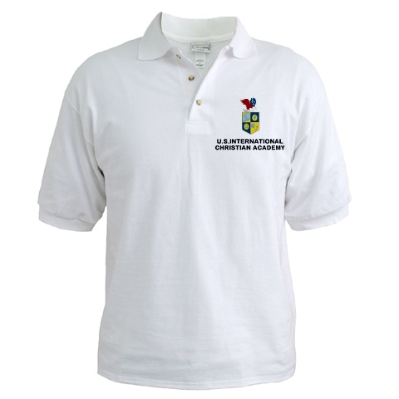

Place your order:
http://www.usicahs.org/e-Store.html

