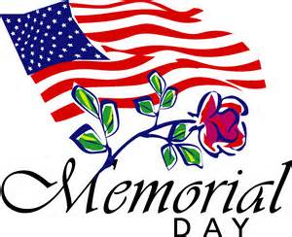

Memorial Day 2014 is on May 26
This day is set aside to celebrate and honor United States men and women
who have died serving their country in military.
Memorial Day originally began to honor and celebrate Union Soldiers who died
during the American Civil War.
Happy Memorial Day

U.S. INTERNATIONAL CHRISTIAN ACADEMY
www.usicahs.org
admin@USICAHS.ORG

