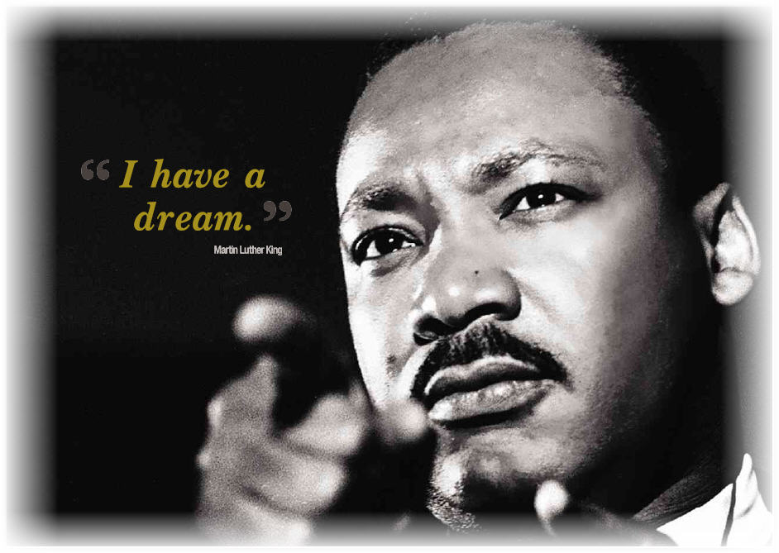

Happy Martin Luther King Jr. Day
U.S. INTERNATIONAL CHRISTIAN ACADEMY
an independent, international autonomous global high school institution

www.USICAhs.org
admin@USICAhs.org

In observance of Martin Luther King, Jr., U.S. International Christian Academy will be closed
Monday, January 19th, 2015January 20th, 2015

