U.S. INTERNATIONAL CHRISTIAN ACADEMY
Serving students since 2001
Owned and Operated by Teachers
with 25 years of experience in Teaching and Administration
www.usicahs.org
e.mail: admin@USICAHS.ORG

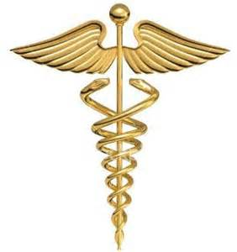
M.D. CORNER

Ebola Virus/Enterovirus D68

Dear Parents/Students

With the focus of the media on a potential health crisis in America about Ebola Virus and Enterovirus D68 and in compliance with the U.S. international Christian Academy School regulations, Miami Dade County, and the Florida Department of Health we are encouraging our students and families to practice healthy habits to avoid spreading illness. Taking certain precautions may be necessary:
- Avoid close contact with sick people
- Wash hands often with soap and water
- Cover coughs and sneezes
- Clean and disinfect surfaces frequently
- Stay home from school when sick
For more information regarding the Enterovirus D68 please see the attached letter from the Florida Department of Health.

