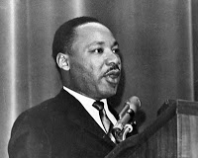

"I have a dream that my four little children will one day live in a nation where they will not be judged by the color of their skin, but by
the content of their character."
Martin L. King, Jr. I Have a Dream Quote

Martin L. King, Jr. Day

U.S. INTERNATIONAL
CHRISTIAN ACADEMY
www.USICAhs.org admin@USICAhs.org

Student Government Association
www.USICAsga@yahoo.com
http://www.usicahs.org/Student-Life-.html

