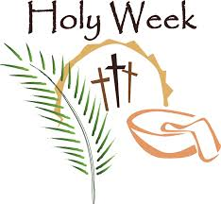

Sunday March 29 Palm Sunday
Good Friday April 3
Sunday, April 5 Easter Day

Holy Week is the last week of Lent, the week immediately preceding
Easter Sunday.
It is observed in many Christian churches as a time to commemorate and enact the suffering (Passion) and death of Jesus through various observances and services of worship. While some church traditions focus specifically on the events of the last week of Jesus’ life, many of the liturgies symbolize larger themes that marked Jesus’ entire ministry. Observances during this week range from daily liturgical services in churches to informal meetings in homes to participate in a Christian version of the Passover Seder.
Happy Easter..Sunday, April 5, 2015

In Observance of Holy Week USICA High School will be closed
Wednesday April 1- Sunday, April 5, 2015

U.S. INTERNATIONAL CHRISTIAN ACADEMY
is an independent, international autonomous global high school institution
www.USICAhs.org
admin@USICAhs.org

