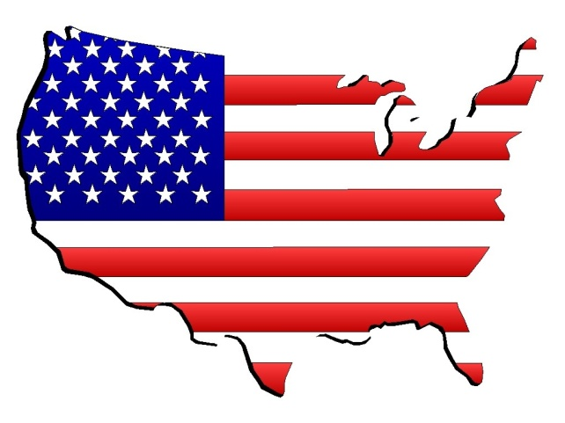
Flag Day Celebration
In the United States, Flag Day is celebrated on June 14. It commemorates the adoption of the flag of the United States, which happened on that day in 1777 by resolution of the Second Continental Congress.^{[1]}The United States Army also celebrates the Army Birthday on this date; Congress adopted "the American continental army" after reaching a consensus position in the Committee of the Whole on June 14, 1775.
In 1916, President Woodrow Wilson issued a proclamation that officially established June 14 as Flag Day; in August 1949, National Flag Day was established by an Act of Congress. Flag Day is not an official federal holiday. Title 36 of the United States Code, Subtitle I, Part A, CHAPTER 1, § 110^{[4]} is the official statute on Flag Day; however, it is at the President's discretion to officially proclaim the observance. On June 14, 1937, Pennsylvania became the first U.S. state to celebrate Flag Day as a state holiday, beginning in the town of Rennerdale.^{[1]} New York Statutes designate the second Sunday in June as Flag Day, a state holiday.

Happy Flag Day

U.S. INTERNATIONAL CHRISTIAN ACADEMY
www.usicahs.org
admin@USICAHS.ORG

