U.S. INTERNATIONAL CHRISTIAN ACADEMY
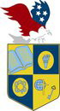
Serving students since 2001
Owned and Operated by Teachers
with 25 years of experience in Teaching and Administration
www.usicahs.org
e.mail: admin@USICAHS.ORG

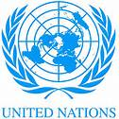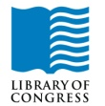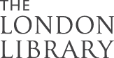
http://www.usicahs.org/Library.html
http://www.usicahs.org/Curriculum.html

U.S. International Christian Academy
Courses by Departments

SCIENCE
Course Physical Science 2000
Course Earth and Science 2001
Course Biology 2002
Course Chemistry 2003
Course Life Science 8003 *

ENGLISH
Course English Composition & Literature 4000
Course World Literature 4001
​Course English Writing & Grammar 4002
Course English Literature 4003

SOCIAL STUDIES
Course World Geography 3000
Course American Government 3001
Course American History 3002
Course Psychology 3003
Course Economics 8001*
Course History American Nation 8004*
Course World History 8002*

MATH
Course Algebra I000
Course Advanced Mathematics 1001
Course Geometry 1002
Course Algebra I 1003
Course Business Math 1004

HEALTH​
Course Health Wellness 5001
Course Health 8000 *

FOREING LANGUAGES
Course Spanish Grammar 7000
Course Spanish Literature 7001

RELIGION
​Course Religion 6000 *
Course Religion 6001 Bible I
Course Religion 6002 Bible II

ART
Course Fine Art 9000

*Electives

