U.S. INTERNATIONAL CHRISTIAN ACADEMY
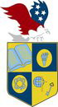
is an independent, international autonomous global high school institution

Serving students since 2001
Owned and Operated by Teachers
25 years of experience in Teaching and Administration
www.USICAhs.org
admin@USICAhs.org

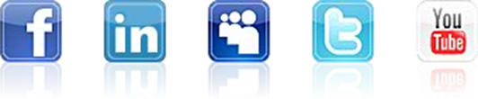
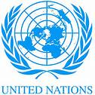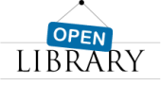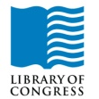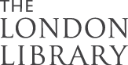
http://www.usicahs.org/Library.html
http://www.usicahs.org/Curriculum.html

U.S.I.C.A. Course Outline/Syllabus
Grade/Course: ART HISTORY 0100330
Grade Level: 11th High School
A)TEXT BOOK: Art of the Western World: From Ancient Greece to Post Modernism Paperback– December 15, 1991
ISBN-ISBN-10: 0671747282 13: 978-0671747282
Order No.: 1 |  | Code: ART 9000 | Class Type: Online
Resources:  Text book  Teacher works CD Teacher interactive online  Links |  |  | Instructional Supports:  Textbook, Magazines, Journals, Websites Links, Conference, Comprehensive Reading Plan, Photos and Videos.
Sky Conference  Videos |  | Length: 1 year
Area: Fine Art |  | Credits: 1 | Total Numbers of class hours: 300 hrs
Type: Mandatory |  | Standards: | Prerequisite:  None

B) Description:

This one-year course of Art is designed to develop the student's understanding of basic concept of art in history.

Topics covered understanding art from Pre-history art to the present art.

C) Objectives:

- To develop in all students an appreciation and understanding for Art.
- to develop in all students analytical, reasoning, and critical thinking skills of Art.
- to promote the study of Art.

D) Contents

Chapter 1
The Art of Greece
Chapter 2
The Roman World
Chapter 3
The Triumph of Faith Western Art 1100
Chapter 4
The Age of Cathedrals
Chapter 5
The Drawn of a New Era: Italian Art
Chapter 6
The early Renaissance
Chapter 7
The north in the Fifteenth Century
Chapter 8
Italian Art
Chapter 9
Art for Popes and Princes
Chapter 10
Dutch Art
Chapter 11
The Art of the Eighteenth Century
Chapter 12
Art as Emotions
Chapter 13
New Reality
1850-1900
Chapter 14
The Art of Twentieth
Chapter 15
Art Between the Wars
Chapter 16
The Triumph of Modernism 1918-41
Chapter 17
Art in the Post-Modern Era

E. Methodology
E)Academic Methodology:

Tests | 30%
Writing Reports | 20%
Homework | 5%
Class Work | 20%
Reading Assignment | 25%

F) Book Reference:
1. Art Book by Editors of Phaidon Press (Apr 17, 1997)
2. Art Is... by The Metropolitan Museum of Art (Oct 22, 2013)
3. Art: Over 2,500 Works from Cave to Contemporary by Andrew Graham-Dixon (Oct 20, 2008)
4. Encaustic Art: The Complete Guide to Creating Fine Art with Wax by Lissa Rankin (Aug 10, 2010)
5. Donald Verger Signature Landscape 2015 Fine Art Nature Wall Calendar 12X12 Staple Bound - Storms, Landscapes,... by Donald Verger Photography
6. Art: A World History by Elke Linda Buchholz, Susanne Kaeppele, Karoline Hille and Irina Stotland (Nov 1, 2007)
7. Legends of the Madonna as Represented in the Fine Arts by Droid Ebooks (Jul 12, 2011)

H) Web Reference:

www.fine-art.com
www.conceptualfinearts.com
http://fineartanddesign.com/links
www.artcyclopedia.com/links.html

I. Journals:

American Journal of Art
Art Educational Journal

J.Magazines:

Art in America
Art International (Paris, France)
ArtAsiaPacific (Asia and the Middle East)
Art of England
Art on paper
ARTnews
ArtReview (London)
Arts Magazine

K. Organizations:

National Art Educational Association
The National Endowment for the Arts

M. Comprehensive Reading Plan
Students are required to read at least 1 book or their equivalent during each class
as independent reading at-home. Students must also read for 30 minutes at home as part of their daily homework assignment in all subjects. Check your Class Reading Assignment at www.USICAhs.org/CURRICULUM and check free ebooks at www.openlibrary.org .

Text Book Description:

Art of the Western World: From Ancient Greece to Post Modernism Paperback– December 15, 1991 by Bruce Cole(Author)
ISBN-ISBN-10: 0671747282 13: 978-0671747282
In this magnificently illustrated and comprehensive book, readers will take one of the most beautiful journeys our world has to offer: an exploration of the greatest are and architecture of Western civilization. Art of the Western World -- the companion volume to the nine-part PBS television series -- traces the history of Western art from its classical roots in ancient Greece up to the present day and the international Post-Modernism of artists as diverse as Christo, Hockney, and Kiefer. Along the way experts Bruce Cole and Adelheid Gealt carefully chart the evolution of the Western tradition, from the grandeur of Roman architecture to the symbolic language of medieval art, through the unparalleled achievements of the Renaissance, the turbulent emotionalism of the Romantics like Turner and Constable, the Impressionists' search for a new reality, and the revolution of the Abstract Expressionists of the twentieth century.
Art of the Western World integrates the works of each period with the history, values, and ideals that gave birth to them: the influence of the Medicis and other great patrons of Renaissance Italy; the resurgence of the classical style, inspired by the French Revolution; the break with the past evidenced in the works of the Impressionists; and the tortured visions of the modern world devastated by wars depicted in the paintings of Picasso, Marc, Groez, and others.
A valuable key to understanding the language of art, Art of the Western World offers fresh insight into what the great works meant at the time they were created and why they maintain their special meaning to us now. It is the perfect guide to the masterpieces of Western art.

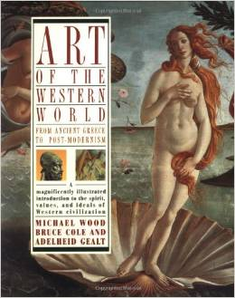

ACADEMIC MISCONDUCT:
Academic misconduct includes cheating (using unauthorized materials, information, or study aids in any academic exercise), plagiarism, falsification of records, unauthorized possession of examinations, intimidation, and any and all other actions that may improperly affect the evaluation of a student’s academic performance or achievement, or assisting others in any such act or attempts to engage in such acts. Academic misconduct in any form is inimical to the purposes and functions of the school and therefore is unacceptable and prohibited.
Any faculty member, administrator or staff member may identify an act of academic misconduct and should report that act to the department head or administrative supervisor.
Students violating the standards of academic honesty are subject to disciplinary action including reduction of a grade(s) in a specific course, assignment, paper, or project; a formal or informal reprimand at the professorial, dean, or academic vice president level; expulsion from the class in which the violation occurred; expulsion from a program; or expulsion from the school.

U.S. International Christian Academy © 2013
Revised on January 6, 2013 USICA Copyright

