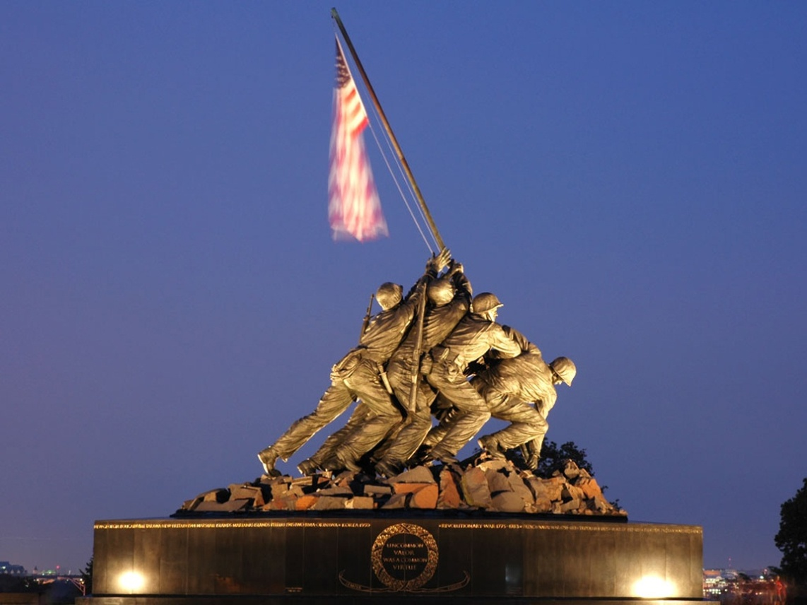
Happy Memorial Day….

In observance of Memorial Day,
U.S. International Christian Academy will be closed
Monday May 30, 2016
U.S. INTERNATIONAL CHRISTIAN ACADEMY
www.usicahs.org
admin@USICAHS.ORG

