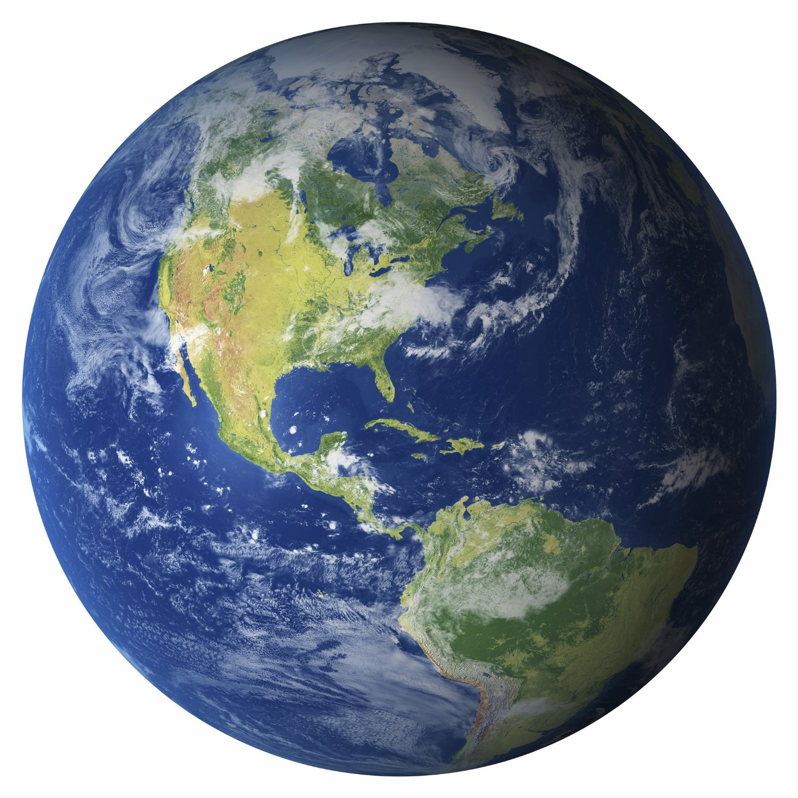

Earth Day Celebration
Friday, April 22, 2016

U.S. INTERNATIONAL CHRISTIAN ACADEMY

www.usicahs.org
admin@USICAHS.ORG

