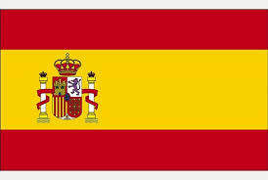
ESPAÑA

Capital | Madrid
Government | Unitary state, Monarchy, Constitutional monarchy, Parliamentary system
Currency | Euro (EUR)
Official language | Spanish
Population | 47,737,941
Religion | Roman Catholic
Crops | Spain produces large crops of wheat, barley, vegetables, tomatoes, olives, sugar beets, citrus fruit, grapes, and cork. Spain is the world's largest producer of olive oil and Europe's largest producer of lemons, oranges, and strawberries.
Most Popular Sport | Soccer
Type of Music | Flamenco, Zarzuela
United Nations | - Spain is and has been a member of the United Nations since December 12, 1955
Interesting Facts | - In Spain they drive on the right-hand side of the road.  - The name Spain comes from the word Ispania, which means the land of rabbits  - Spain is the only country in Europe that produces bananas  - The Spaniards invented the mop.  - The name Madrid comes from the Arabic “magerit” which means ‘place of many streams’.

